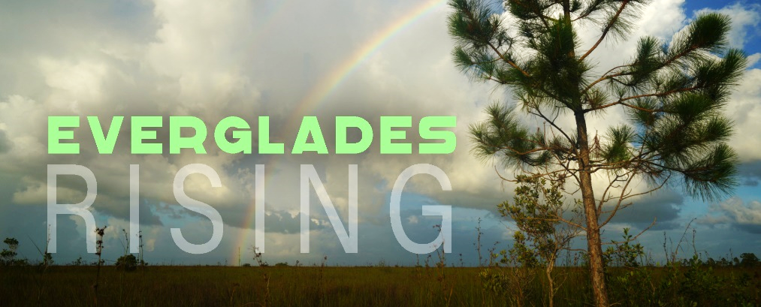
Teacher’s Guide
Intro
Living in South Florida means you are surrounded by natural treasures. This is home to 4 national park units. In fact there are no other national parks anywhere else in our state. We have Biscayne National Park, 95% of which is marine habitat. We also have the wild and remote Dry Tortugas National Park, full of rich history and vibrant sea-life. Big Cypress National Preserve contains over 700,000 acres of wilderness and a variety of wetland and upland habitats. It also shares a boundary line with Everglades National Park and is part of the larger Everglades bioregion.

Everglades National Park was the first National Park established specifically to protect an ecosystem and is home to several threatened and endangered species such as the American crocodile and the Florida panther. Unfortunately, the Everglades faces many threats including climate change, invasive species and development. Approximately half of the historical Everglades bioregion has been lost to development and agriculture.

Part 1- The Ecosystem
Florida NGSSS

Grade 2

SC.2.L.17.2 Recognize and explain that living things are found all over Earth, but each is only able to live in habitats that meet its basic needs.

SC.2.N.1.1 Raise questions about the natural world, investigate them in teams through free exploration and systematic observations, and generate appropriate explanations based on those explorations.

Grade 3
- SC.3.N.1.1 - Raise questions about the natural world, investigate them individually and in teams through free exploration and systematic investigations, and generate appropriate explanations based on those explorations.
- SC.3.N.1.2 -Compare the observations made by different groups using the same tools and seek reasons to explain the differences across groups.
- SC.3.N.1.3 - Keep records as appropriate, such as pictorial, written, or simple charts and graphs, of investigations conducted.

Grade 4
- SC.4.N.1.1 - Raise questions about the natural world, use appropriate reference materials that support understanding to obtain information (identifying the source), conduct both individual and team investigations through free exploration and systematic investigations, and generate appropriate explanations based on those explorations.
- SC.4.N.1.6 - Keep records that describe observations made, carefully distinguishing actual observations from ideas and inferences about the observations.

Grade 8

SS.8.G.3.1 Locate and describe in geographic terms the major ecosystems of the United States.

Grade 912

SC.912.L.17.2 Explain the general distribution of life in aquatic systems as a function of chemistry, geography, light, depth, salinity, and temperature.

SC.912.L.17.7 Characterize the biotic and abiotic components that define freshwater systems, marine systems and terrestrial systems.

Everglades Literacy Connections:
https://www.evergladesliteracy.org/third-grade
https://www.evergladesliteracy.org/9th-12th-amazing-adaptations

Habitats
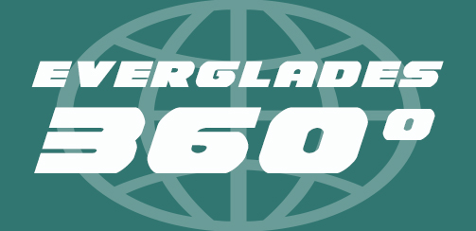
Go on a virtual “scavenger hunt” and experience Everglades habitats in 360 degrees, thanks to immersive VR video!

When you picture the Everglades, what do you think of? I’m guessing you see the image of an endless, watery prairie full of sawgrass and teeming with wading birds, moccasins and alligators. But the Everglades is more than just water and sawgrass. True, the “River of Grass” is famous for its prairie wetlands. But it is also a complex mosaic of many important habitats. One thing that is especially fascinating about the Everglades, is that sometimes only a few inches of elevation change can result in a completely different habitat.

Pine rockland: Pine rocklands get their name from the slash pines that grow on limestone ridges in South Florida. Over 200 other species of plants also make up the pine rockland community. Amazingly, about 20 percent of the plant species here grow nowhere else in the world! Sadly, however, this is now a globally imperiled habitat. Only about 2 percent of the pine rocklands that used to cover South Florida remain.

Pine rocklands require one thing you might not expect: fire. The plants that grow here have adapted to resist and even rely on the occasional blaze. The thick, flaky bark of the slash pine, for example, protects its inner trunk from heat. Its branches sprout high in the canopy. Ash that’s left behind adds important nutrients to the soil. Fire also prevents succession, by killing invading plants that are not as fire resistant. Without fire, in fact, other species of plants would eventually take over, and the habitat would likely change into a hardwood hammock.
Succession is the natural replacement of plant species in a habitat as the environmental conditions change over time

Pine rockland species:

Plants |  | Animals
Saw palmetto |  | Bartram’s hairstreak | Eastern indigo snake
Pine rockland croton |  | Miami tiger beetle | Bobcat
Silver palm |  | Florida box turtle | Florida bonneted bat

Hardwood hammock: An egret’s view of the Everglades reveals islands dotting the prairies, tear-drop shaped by the slow-moving water. These are hardwood hammocks: jungly, humid tree islands, offering high ground for terrestrial animals, shade and shelter for birds.
Many of the plants that grow here are tropical species. Most of them, even the large trees, produce small berries. Why is that important? Well it’s important to understand how these tropical plants got to Florida to begin with, and the small size of their fruits is important. If a migratory bird eats a poisonwood berry in Cuba, for example, or a gumbo limbo seed in Mexico, it would be possible to transport that seed in its belly on its journey north. So there it is. A lot of our tropical plants in Florida are here because of bird poop. Fascinating.

Hardwood hammock species:

Plants |  | Animals
Gumbo limbo |  | Liguus tree snail | Racoon
Poisonwood |  | Painted bunting | Barred owl
Mahogany |  | Armadillo | Florida panther

Cypress dome: From a distance, a cypress dome might look like a similar habitat to a hardwood hammock, or maybe a pine rockland. Afterall, it is a towering forest of tall trees, mostly pond cypress trees. Slog into one and you’ll see that it is completely different. Did you notice I said “slog?”

Instead of growing on elevated areas of dry land, cypress trees like wet, swampy areas. They tend to grow in depressions, often springing up around solution holes or ponds excavated by alligators seeking water during the dry season.

Cypress dome species:

Plants |  | Animals
Pond cypress |  | Blue gill | Great egret
Pond apple |  | Largemouth bass | Water moccasin
Ghost orchid |  | Florida softshell turtle | American alligator

Marl prairie: This grassy, shallow wetland habitat dominates much of the Everglades. This is probably what you pictured earlier, the quintessential “River of Grass” nickname coined by author Marjorie Stoneman Douglass. As fresh water in the northern Everglades slowly drifts through the marl prairie, the plants suck up many of the nutrients, helping to purify that water before it reaches the coast.

These prairies change dramatically with the seasons. During the rainy season they fill with water for several months, however during the dry months in late winter and springtime, they can dry down completely.

Marl prairie species:

Plants |  | Animals
Sawgrass |  | Mosquito fish | Cape Sable seaside sparrow
swamp lily |  | Sailfin molly | White-tailed deer
bladderwort |  | Pig frog | Great blue heron

Slough: This is a channel of deeper water, often fringed by shallower marl prairies. Sloughs are more likely to hold water during the dry season and are important for keeping fresh water flowing into Florida Bay. The Everglades has two main sloughs: the Shark River Slough and Taylor Slough.

Slough species:

Plants |  | Animals
Spatterdock |  | Largemouth bass | Anhinga
Alligator flag |  | Apple snail | River otter
Water lily |  | Snail kite | American alligator

Mangrove fringe: The ultimate destination of the River of Grass is the sea. As you get close to the coast, you start to notice forests of trees, some growing in the shallow coastal waters, anchored to the seafloor by looping “prop-roots.” These are red mangrove trees, a common species in tropical, coastal areas around the world.
South Florida has 4 species of trees that are considered “mangrove” trees, not all closely related. What they have in common is that they can grow in shallow, salty water. Above water they are nesting and roosting grounds for birds. Below water, their roots (especially those of the red mangrove) provide shelter for fish and other marine life.

Mangrove fringe species:

Plants |  | Animals
Red mangrove |  | Mangrove crab | Osprey
White mangrove |  | Sergeant major | Lemon shark
Black mangrove |  | Mangrove snapper | American crocodile
Buttonwood

Seagrass meadows: Florida Bay is a large estuary fed by the fresh waters of the Everglades which mix with the salty waters of the Gulf of Mexico. This estuary is a critical nursery ground for many species of fish and other marine life, and the most important habitats for them are the huge meadows of seagrass. These seagrasses are food for animals like sea turtles and manatees, and are ideal for little fish and invertebrates to hide in.

Sea grasses grow best in water that is relatively shallow, and water that is clean and clear. That’s because, like terrestrial grasses, they manufacture food energy through photosynthesis.

Seagrass meadow species:

Plants |  | Animals
Turtle grass |  | Upside-down jellyfish | Green sea turtle
Manatee grass |  | Permit | West Indian manatee
Shoal grass |  | Bonefish | Long tooth sawfish

The Watershed and Everglades Hydrology

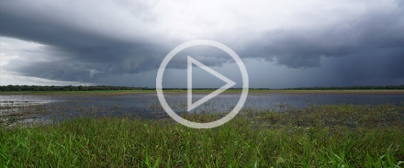
Video Adventure
The Everglades: River of Grass

Florida NGSSS
Grade 6
- SC.6.N.3.4 - Identify the role of models in the context of the sixth grade science benchmarks.
- SC.6.E.6.2 - Recognize that there are a variety of different landforms on Earth's surface such as coast-lines, dunes, rivers, mountains, glaciers, deltas, and lakes and relate these landforms as they apply to Florida.
Grade 7
- SC.7.E.6.6 - Identify the impact that humans have had on Earth, such as deforestation, urbanization, desertification, erosion, air and water quality, changing the flow of water.
Grade 8
- SC.8.N.4.2 - Explain how political, social, and economic concerns can affect science, and vice versa.
Grade 912

SC.912.L.17.7 Characterize the biotic and abiotic components that define freshwater systems, marine systems and terrestrial systems.

SC.912.L.17.8 - Recognize the consequences of the losses of biodiversity due to catastrophic events, climate changes, humanactivity, and the introduction of invasive, non-native species.

SC.912.L.17.16 - Discuss the large-scale environmental impacts resulting from human activity... and surface and groundwater pollution.

SS.912.G.3.5 Use geographic terms and tools to explain how hydrology influences the physical character of a place.

Everglades Literacy Connections:
https://www.evergladesliteracy.org/sixth-grade
https://www.evergladesliteracy.org/seventh-grade
https://www.evergladesliteracy.org/eighth-grade
https://www.evergladesliteracy.org/9th-12th-our-watershed

In 1947, author Marjory Stoneman Douglas published a ground-breaking book. It exposed the world to a wonderful ecosystem that unfortunately was suffering from human impacts. “The Everglades: River of Grass” borrowed its title from the Seminole phrase, Pa-hay-Okee, meaning “grassy waters.” It also gave the Everglades its famous nick-name.

Before the Everglades was tamed, outsiders viewed it as a swampy wasteland, full of venomous snakes and stagnant water. But this is not a stagnant swamp at all. As Marjory Stoneman Douglas argued, it is in fact a shallow, slow moving river about 60 miles wide and 100 miles long.

Historically, the story of the Everglades began near Orlando, where rainwater fed a chain of lakes. These lakes then flowed into the Kissimmee River, which in turn flowed into Lake Okeechobee. Lake Okeechobee would then over-spill along its southern rim, giving birth to the River of Grass.

From the headwaters of the River of Grass, the elevation drops only a few inches per mile through the Everglades all the way to Florida Bay. Water goes where gravity takes it, and in this case, it flows like a wide sheet of water.
Sheet-flow: a term used to describe the slow, broad and shallow movement of water across a flat plane, rather than being concentrated in deeper channels

The foundation of South Florida is a platform of limestone called the “Biscayne Aquifer.”
Aquifer: a body of porous rock or sand that holds groundwater

During the dry season, the bedrock becomes exposed in jagged formations of pinnacle rock. Where it has dissolved away, solution holes form.
Solution hole: a depression in the ground which is formed gradually over time when limestone erodes or is dissolved

Some of the water drifting through the Everglades seeps downward, “re-charging” the groundwater. This is incredibly important. For about 8 million South Floridians, the Biscayne Aquifer is our primary source of fresh water and that water ultimately comes from the Everglades.

Part 2- Web of Life

Florida NGSSS

Grade 3

SC.3.L.17.2 Recognize that plants use energy from the Sun, air, and water to make their own food.

Grade 4

SC.4.L.17.2 Explain that animals, including humans, cannot make their own food and that when animals eat plants or other animals, the energy stored in the food source is passed to them.

SC.4.L.17.3 Trace the flow of energy from the Sun as it is transferred along the food chain through the producers to the consumers.

Grade 7

SC.7.L.17.1 Explain and illustrate the roles of and relationships among producers, consumers, and decomposers in the process of energy transfer in a food web.

Grade 912

SC.912.L.17.9 Use a food web to identify and distinguish producers, consumers, and decomposers. Explain the pathway of energy transfer through trophic levels and the reduction of available energy at successive trophic levels.

Everglades Literacy Connections
https://www.evergladesliteracy.org/fourth-grade

Video Adventures
The Food Chain Trilogy

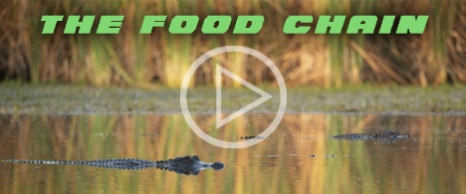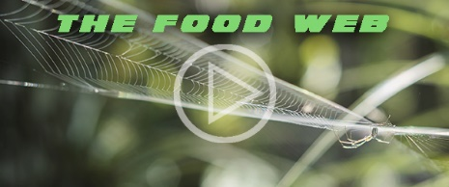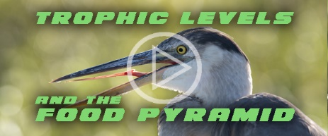

The Everglades exists in a complex balance of biotic and abiotic elements.
Biotic elements: the living things…the plants, the animals and the ways they interact with each other

Abiotic elements: the non-living things…the water, the geology, the climate and disturbances such as fire

Every native species of plant and animal has adapted to fill a special niche, occupying an important role in this delicate web of life. Undisturbed, there is balance and life is good.

Where there is light, we find life. Autotrophs, or “producers” are able to harness the energy of the sun, transforming light energy into chemical energy through the process of photosynthesis. These plants are the first link in the food chain. Without them we wouldn’t have the heterotrophs, or “consumers,” which make up the following links in the chain.
Autotroph: an organism that can produce its own food using light, water, carbon dioxide, or other chemicals. A primary producer.

Heterotroph: an organism that eats other plants or animals for energy and nutrients. A consumer.

We are going to construct a typical Everglades food chain, starting with a primary producer.
Slogging through the marl prairie, you’ll notice a yellowish, spongy goo that coats the floor and clings to the aquatic plants. This stuff is called periphyton, and it’s super important. Scoop up a handful and you’ll see how it absorbs and holds water, which is crucial when the Everglades dries down during the winter and spring months.

Periphyton: a complex community of algae, fungi, cyanobacteria, microorganisms and detritus which forms the base of the food chain in much of the Everglades.
Primary Producer –

Primary consumer - Mosquito larvae: In its larval form, the mosquito is an aquatic herbivore. It feeds on organic detritus, as well as periphyton.

Secondary consumer - Gambusia: This common freshwater minnow is also called the “mosquito fish,” for an obvious reason. Its favorite food is mosquito larvae.

Tertiary consumer - Great blue heron: This large wading bird has stilt-like legs, allowing it to wade into water just deep enough to spear its favorite food: fish. It can snag some pretty big prey, but gambusia is a nice appetizer.

Top predator - American alligator: This ancient survivor is like a living dinosaur. It is one of only two species of alligators on the planet. An ambush predator, a full-grown alligator is without a doubt the king of the Everglades.

Part 3- Exotic Everglades

Florida NGSSS

Grade 4
- SC.4.L.17.4 Recognize ways plants and animals, including humans, can impact the environment.
Grade 5
- SC.5.L.15.1 Describe how, when the environment changes, differences between individuals allow some plants and animals to survive and reproduce while others die or move to new locations
- SC.5.L.17.1 Compare and contrast adaptations displayed by animals and plants that enable them to survive in different environments such as life cycles variations, animal behaviors and physical characteristics
Grade 7
- SC.7.L.17.2 Compare and contrast the relationships among organisms such as mutualism, predation, parasitism, competition, and commensalism.
- SC.7.L.17.3 Describe and investigate various limiting factors in the local ecosystem and their impact on native populations, including food, shelter, water, space, disease, parasitism, predation, and nesting sites.
Grade 912
- SC.912.L.17.17 Assess the effectiveness of innovative methods of protecting the environment.
- SC.912.L.17.6 Compare and contrast the relationships among organisms, including predation, parasitism, competition, commensalism, and mutualism.
- SC.912.L.17.8 Recognize the consequences of the losses of biodiversity due to catastrophic events, climate changes, human activity, and the introduction of invasive, non-native species.

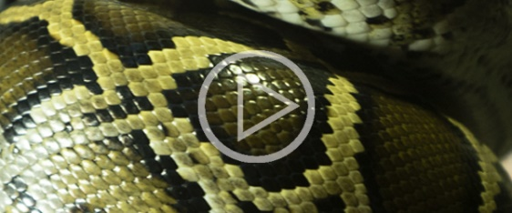
Video Adventure
CONSTRICTED: Florida’s
Exotic Invaders

Some exotic species are relatively harmless to the ecosystem while invasive exotic species are a problem.
Exotic species are plants or animals that are non-native.

Invasive species: a non-native species that can significantly modify or disrupt the ecosystem it colonizes.

South Florida’s subtropical climate has become a comfortable home to a wide variety of invaders, both plant and animal. We find them in practically any body of water, whether it be fresh or marine. Some we just take for granted as if they’ve always been here.

All of these invasive species displace the native ones, outcompeting them for resources and disrupting the natural web of life in the Everglades. And most of them have one thing in common: they were brought here by humans, either intentionally or accidentally.

Melaleuca: This tall Australian tree in the eucalyptus family has taken over huge areas of what used to be marl prairie and is very difficult to eliminate.

Brazilian pepper: This South American shrub has also overrun many wilderness areas in South Florida and is difficult to kill. Their small, spicy berries are eaten by many species of birds, and even black bears, which is one reason the Brazilian pepper has spread so extensively.

Water hyacinth: An aquatic plant native to the Amazon basin, water hyacinth can very quickly choke rivers, waterways and wetland areas, pushing out native aquatic plants and preventing light from penetrating.

Wasmannia: the “little fire ant,” or “electric ant” is tiny, but packs a punch. Native to Central and South America, they’ve spread throughout the Caribbean, North America and even parts of Africa.

New Guinea flatworm: these little slimy invaders are a big problem, though you probably rarely see them. One big concern is that they devour snails, including rare native tree snails.

Lionfish: This tropical marine species is a real beauty. A real hungry, venomous beauty. Stay clear of those spines. Lionfish can take over seagrass beds, coral reefs…pretty much any reasonably shallow marine habitat. They are, however, delicious to eat.

Argentine tegu: This large, predatory lizard from South America is getting a lot of attention, for good reason. A favorite food is eggs: Bird eggs, alligator eggs, crocodile eggs…pretty much any kind of eggs.

Burmese python: For thousands of years, the alligator was the uncontested apex predator of the Everglades. But today this crocodilian competes with an infamous invader for the top spot.
Growing as long as 19 feet, the Burmese python is a hungry constrictor can give the alligator a run for its money. What’s worse, they are taking over and eating just about anything that moves.

Humans: This species has two legs and a large brain, and has caused more damage to the Everglades by far than any other.

Part 4- Human Invasion
The Altered Watershed and Everglades Restoration
Humans are smart, but we don’t always think ahead and to be honest, we often do some dumb things. The Everglades is a prime example. It all started over 100 years ago, when efforts began to literally “drain the swamp.”

Early settlers discovered that South Florida’s warm climate was perfect for growing crops all year round. But much of the region was covered with swampy marshes…great for alligators, not agriculture. If the wetlands could be drained, however, there would be plenty of land for crops and development.

So canals were dug to channel the water away from the Everglades, and a massive dike was built around Lake Okeechobee, preventing seasonal flooding and blocking the southern flow of water. These projects helped create the Everglades Agricultural Area where the headwaters of the River of Grass used to be. Today the EAA is like a giant cork in the Everglades bottle. Instead of sawgrass, we now find sugar cane….hundreds of thousands of acres of sugar cane.

If that wasn’t bad enough, Lake Okeechobee was becoming more and more polluted from agricultural runoff and cattle farms to the north. Since its waters couldn’t flow into the Everglades as it used to, two rivers were altered to divert that water east and west. Today, when water is released from Lake O through the Caloosahatchee and the St. Lucie Rivers, its nutrient-rich contents contaminate important estuaries on the west coast and the east coast. Fish die. Oyster beds collapse and nasty blooms of blue-green algae are becoming more and more common.

Meanwhile, the southern Everglades and Florida Bay are dying of thirst and Everglades Restoration efforts have a new sense of urgency. These projects include new reservoirs and filter marshes to store and clean the water, pump stations to move it and elevated bridging over Tamiami Trail to allow that water to flow into the southern Glades.

Climate change

Climate change is on everyone’s mind, because it will affect everyone. Global warming, sea level rise and changes to the planet’s weather patterns are a serious concern to our ecosystems, the earth’s biodiversity and our very survival as humans. Unfortunately, mankind’s reliance on fossil fuels is what is likely “fueling” this problem. The good news is, humans are intelligent and creative. To tackle this problem, we really need to work together.

Climate change has opened our eyes to a threat that could have huge impacts on the Everglades and all of us in South Florida. Most us live in houses perched just above sea-level. That means a couple of feet of sea level rise could have catastrophic consequences.

While we can observe the waters rising above ground, we can’t easily see what’s happening below. But we can taste it. I’m talking about something called saltwater intrusion.
Saltwater intrusion is the movement of salt water into freshwater aquifers

We remember that the aquifer below us is like a rocky sponge that holds water. As you get closer to the coast, the ground water becomes more and more salty from the sea-water that seeps in and mixes with the fresh water. As sea-levels rise, the result is more pressure pushing that seawater further into the aquifer, further inland. Some wells near the coast that used to draw up pure fresh water 100 years ago, are now full of undrinkable salt water. As sea levels continue to rise, this problem will only get worse, unless we do something about it.

So what is the solution? Well, obviously we need to tackle global climate change. But what the Everglades also needs, what South Florida needs, is more water - more clean, fresh water flowing into the system. Freshwater flow through the River of Grass is what “recharges” the aquifer below. This creates the pressure necessary to push back against invading seawater. It may seem like a simple fix, but it requires lots of good science, lots of hard work, and lots of citizens who care enough to demand solutions to fix our Everglades, the source of pure, fresh water for more than 8 million people. Sea levels are rising. Can we help the Everglades rise to the challenge?

For more Everglades educational resources, visit:

https://www.nps.gov/ever/learn/education/index.htm
https://www.evergladesliteracy.org/resources

Vocabulary
Fill in the letter of the corresponding definition that best matches the vocabulary word

Solution hole |  |  | A | the natural replacement of plant species in a habitat as the environmental conditions change over time
Biotic elements |  |  | B | an organism that can produce its own food using light, water, carbon dioxide, or other chemicals. A primary producer
Succession |  |  | C | a term used to describe the slow, broad and shallow movement of water across a flat plane, rather than being concentrated in deeper channels
Aquifer |  |  | D | a depression in the ground which is formed gradually over time when limestone erodes or is dissolved
Autotroph |  |  | E | the living things in an ecosystem: the plants, the animals and the ways they interact with each other
Heterotroph |  |  | F | the non-living things in an ecosystem: the water, the geology, the climate and disturbances such as fire
Exotic species |  |  | G | the movement of salt water into freshwater aquifers
Abiotic elements |  |  | H | a complex community of algae, fungi, cyanobacteria, microorganisms and detritus which forms the base of the food chain in much of the Everglades
Periphyton |  |  | I | plants or animals present in an ecosystem that are non-native
Invasive species |  |  | J | an organism that eats other plants or animals for energy and nutrients. A consumer
Sheet-flow |  |  | K | a body of porous rock or sand that holds groundwater
Saltwater intrusion |  |  | L | a non-native species that can significantly modify or disrupt the ecosystem it colonizes

Multiple Choice
Circle all that apply

- Which of the following is true of pine rockland habitats?
A | They grow in watery depressions in the limestone |  | B | This habitat has adapted to frequent forest fires
C | Many species of plants here only grow in pine rockland habitats |  | D | The dominant tree here is the pond cypress

- Which species might you encounter in a cypress dome habitat?
A | Ghost orchid |  | B | Pond apple
C | American crocodile |  | D | Turtle grass

- What is the source of the freshwater contained in the Biscayne Aquifer?
A | Biscayne Bay |  | B | Zephyrhills
C | Florida Bay |  | D | Water flowing across the Everglades

- Which animals eat periphyton?
A | Great blue heron |  | B | New Guinea flatworm
C | Mosquito larvae |  | D | Richard Kern

- What is the favorite food of the Argentine tegu?
A | Eggs |  | B | Tree snails
C | Periphyton |  | D | Fresh water crayfish

Construct an Everglades Food Chain
Fill in the blanks with the correct organisms from the list below. Use only native, Everglades species.
Primary
Producer
Top
Predator
Tertiary
Consumer
Secondary
Consumer
Primary
Consumer

_______________ _______________ _______________ _______________ _______________
A | Burmese python |  | B | American Alligator |  | C | Periphyton
D | Wasmannia ant |  | E | Gambusia |  | F | Spectacled caiman
G | Water hyacinth |  | H | Great blue heron |  | I | Beaver
J | Mosquito larva |  | K | Snowy owl |  | L | Pitcher plant

True and False - Circle the correct answer
- Fresh water from the Everglades drifts northwest from Florida Bay, into Lake Okeechobee
True |  | False

- Sea level rise can increase the amount of saltwater intrusion into our aquifers
True |  | False

- More freshwater flowing into the Everglades can increase the amount of saltwater intrusion
True |  | False

- The Everglades is the source of drinking water for about 8 million people in South Florida
True |  | False

- The River of Grass needs more, clean fresh water
True |  | False

Answer Key
Vocabulary
Solution hole= D, Biotic elements= E, Succession= A, Aquifer= K, Autotroph= B, Heterotroph= J, Exotic species= I, Abiotic elements= F, Periphyton= H, Invasive species= L, Sheet-flow= C, Saltwater intrusion= G

Multiple Choice
- B&C 2.) A&B 3.) D 4.) C 5.) A

Construct a Food Chain
Top
Predator
Tertiary
Consumer
Secondary
Consumer
Primary
Consumer
Primary
Producer

C, Periphyton J, Mosquito larvae E, Gambusia H, Heron B, Alligator

True and False
- False 2.) True 3.) False 4.) True 5. True

